Resume

***Personal summary***

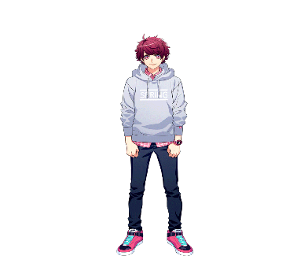

[This Photo](https://yaycupcake.com/a3/index.php?title=File:Sakuya_02_Fullbody.png) by Unknown Author is licensed under [CC BY](https://creativecommons.org/licenses/by/3.0/)

* Name – priyanshu kumar
* Class – 11th
* DOB -20/10/2007
* Marital status – bachelor
* Address -tharmsala wali gali

Educational qualification

* 10th  from G.S.B.V.BIJWASAN BHARTHAL (110077)

Sports qaulification

Cluster from delhi (2021)

Regional from Mumbai (2022)

Regional from Mumbai (2023)